Sanan Huseynov

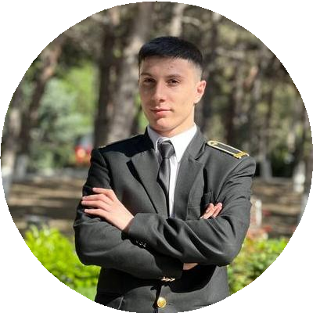

### Backend Developer

Backend Developer with a passion for process automation and a foundation in game and mobile app development. Skilled in C#, Java, C++, with experience in both independent and team projects. Motivated to solve challenging problems and eager to contribute to innovative and fast-paced environments. [senanalonegames@gmail.com [](mailto:senanalonegames@gmail.com)](mailto:senanalonegames@gmail.com)

+994777570122

Baku, Azerbaijan  16 June, 2005 

[](https://instagram.com/snanh01)[linkedin.com/in/sanan-huseynov [](https://linkedin.com/in/sanan-huseynov) [github.com/sanandev05 [](https://github.com/sanandev05) [instagram.com/snanh01](https://instagram.com/snanh01)](https://github.com/sanandev05)](https://linkedin.com/in/sanan-huseynov)

# EDUCATION

## Study Program

### National Aviation Academy

*09/2022 - Present 4.3 GPA*

*Education*

 Process Automation Engineering

# PROJECTS

#### Ball Obstacles Game Development in Unity (06/2020 - 08/2020)

 Used C# OOP

#### Ball Game Development in Unity (10/2022 - 04/2023)

"Yarimillik ve illik qiymətləndirmə " Mobile App for education (02/2024 - 03/2024)

 Mobile App Development in Android Studio  Used XML

 Used JAVA

#### Robot Application (Bootcamp) (02/2024 - 03/2024)

 Used ROS2 framework in Linux

 Used Python  Used C++

 Teamwork

# SKILLS

C#

Java

C++

# COURSES

#### Backend based FullStack programming in Code Academy(09/2024-Present)

*Backend based Full stack Programming*

# CERTIFICATES

#### Volunteering in ASAN Service

RoboCode - Robotic coding camp (02/2024 - 03/2024)

*The 1st Place*

*C programing course (online) in Great Leanring website*

*Digiage Game Development camp(08/2024-09/2024)*

# LANGUAGES

**EXPERIENCE**

## Volunteering

### ASAN Service

*09/2023 - 11/2023 Baku*

*ASAN Volunteers Achievements/Tasks*

 To direct the customers and help, to participate several

project organized by ASAN

English

*Intermediate*

Turkey

*Fluent*

# INTERESTS

Developing personal software projects in my free time.I like watching movie in my free time. I also interested in learning new things.

Azerbaijan

*Native*